**Employee**

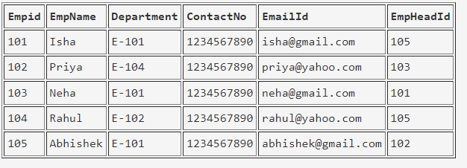

create table employee(empid int primary key,empname varchar(100), department varchar(50),contactno bigint, emaildid varchar(100), empheadid int)

**EmpDept**

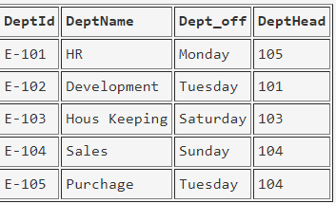

create table empdept(deptid varchar(50) primary key,deptname varchar(100), dept_off varchar(100), depthead int foreign key references employee(empid))

**EmpSalary**

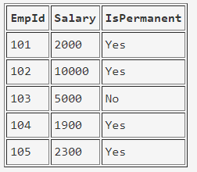

create table empsalary(empid int foreign key references employee(empid), salary bigint, ispermanent varchar(3))

**Project**

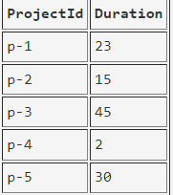

create table project(projectid varchar(50) primary key, duration int)

**Country**

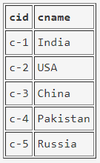

create table country(cid varchar(50) primary key, cname varchar(100))

**ClientTable**

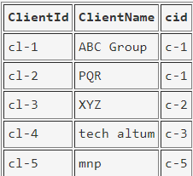

create table clienttable(clientid varchar(50) primary key, clientname varchar(100), cid varchar(50) references country(cid))

**EmpProject**

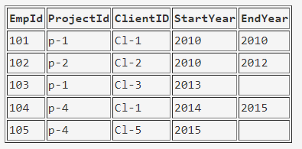

create table empproject(empid int foreign key references employee(empid), projectid varchar(50) foreign key references project(projectid), clientid varchar(50) foreign key references clienttable(clientid),startyear int, endyear int)

**Query:**

1. Select the detail of the employee whose name start with P.

Solution:-

|  |
| --- |
|  |

1. How many permanent candidate take salary more than 5000.

Solution:-

|  |
| --- |
|  |

1. Select the detail of employee whose emailId is in gmail.

Solution:-

|  |
| --- |
|  |

1. Select the details of the employee who work either for department E-104 or E-102.

Solution:-

|  |
| --- |
|  |

1. What is the department name for DeptID E-102?

Solution:-

|  |
| --- |
|  |

1. What is total salarythat is paid to permanent employees?

Solution:-

|  |
| --- |
|  |

1. List name of all employees whose name ends with a.

Solution:-

|  |
| --- |
|  |

1. List the number of department of employees in each project.

Solution:-

|  |
| --- |
| SELECT p.project_id, COUNT(DISTINCT d.department_id) AS number_of_departments  FROM projects p  INNER JOIN employees e ON p.department_id = e.department_id  GROUP BY p.project_id; |

1. How many project started in year 2010.

Solution:-

|  |
| --- |
|  |

1. How many project started and finished in the same year.

Solution:-

|  |
| --- |
|  |

1. select the name of the employee whose name's 3rd charactor is 'h'.

Solution:-

|  |
| --- |
|  |